

**Enabling Good Lives:**

**Vision and Principles**

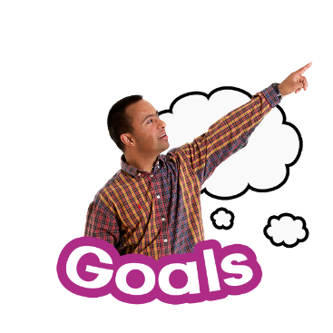

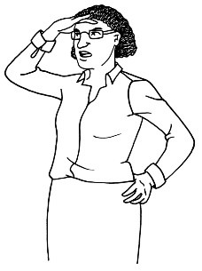

**Easy Read**

cid:03C2CEB5-3D84-4D2D-8742-A7C8E2E71924This document is about the Enabling Good Lives **vision** and **principles**.

A **vision** is like a goal.  
  
The Enabling Good Lives Leadership Group came up with a vision about what they want the future to look like.

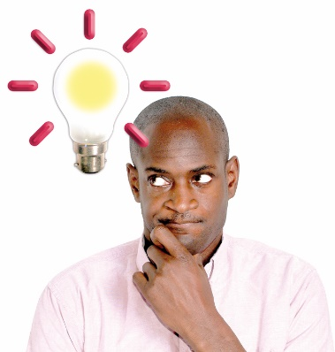

A **principle** is an idea that helps to guide an organisation to reach its goals.

**Vision**

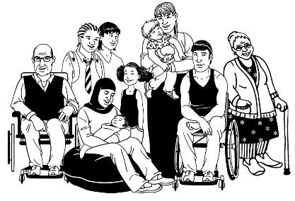  
  
We want to see a future where all disabled people and their families / whānau will:

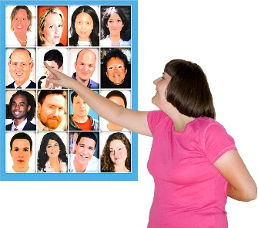

* 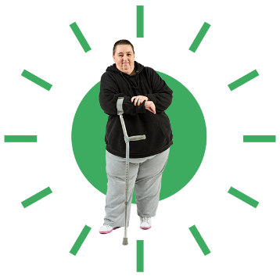have more choice over their lives and supports
* have more control over their lives and supports

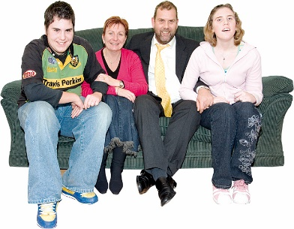

* make more use of **natural** **supports**  
    
  **Natural** **supports** means:
* supports in the community
* the support you get from your relationships with people like family / whānau and friends.



* make more use of **universally available** **supports**.

**Universally available supports** means services that are available to everybody including disabled people.

**Principles**



It will take time to make the vision real.

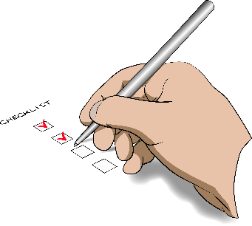

We will need to do a lot of work to make this happen.



We will be able to reach our goal if we follow the principles.

A close up of a logo

Description generated with very high confidence

Enabling Good Lives has **8** **principles**.

**Enabling Good Lives Principles**

A close up of a logo

Description generated with very high confidence

The **8 principles** are:

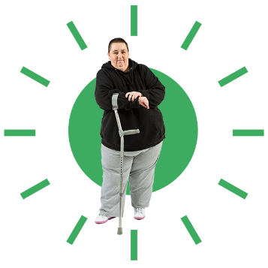

**Principle 1 – Self determination**

This means that disabled people have control over their own life.

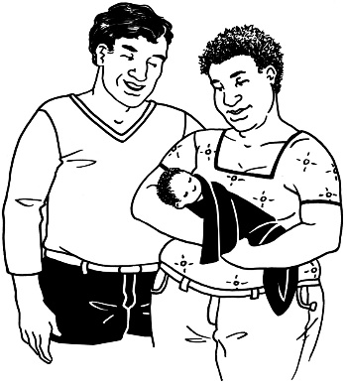**Principle 2 – Beginning early**

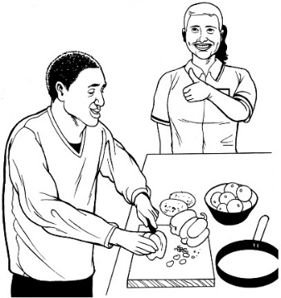Support families / whānau as soon as they find out that their child has a disability.

Disabled children will have the support in place to:

* 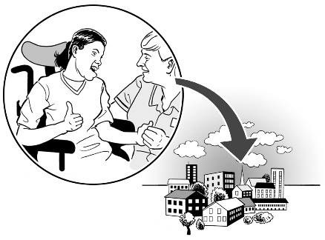live a good life
* take part in community life



* be **independent**.

Being **independent** means you can do things for yourself. **Principle 3 – Person centred**

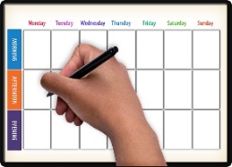Supports are made to work for a disabled person:

* 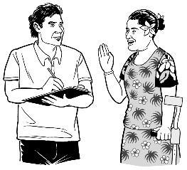when they want it
* 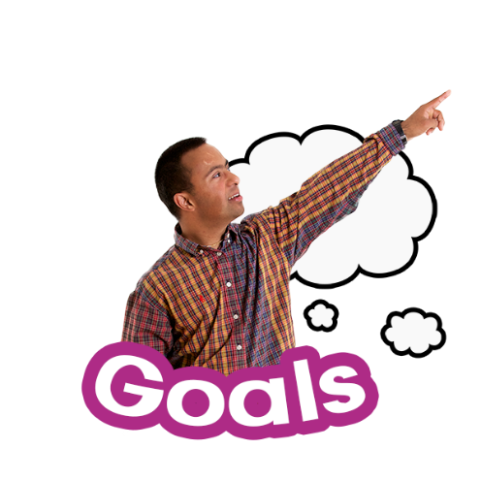in the way they want it.

The supports should assist disabled people to reach their own goals.

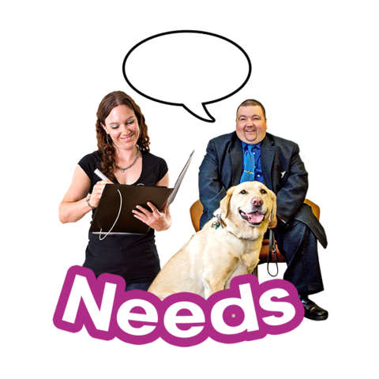

This means supports are **tailored** to the needs of a disabled person.

**Tailored** means something is made or changed to fit 1 person.

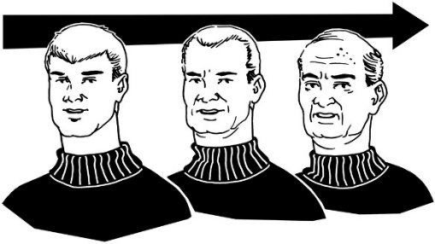**Principle 4 – Ordinary life outcomes**  
Disabled people can do the same things that other people their own age are also doing.

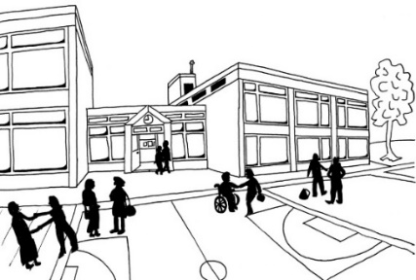  
This means disabled people have the right support to do things like:

* go to school



* get a job

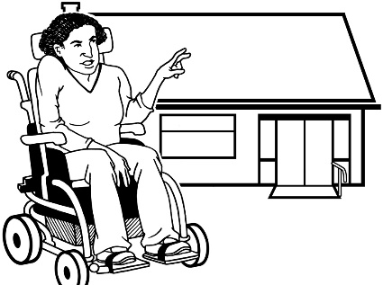

* have a home.

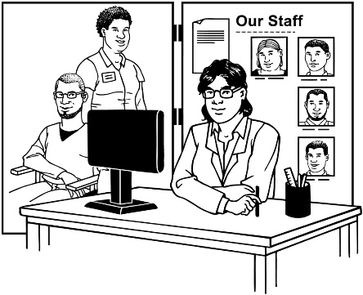**Principle 5 – Mainstream first**Disabled people can use mainstream services that everyone else uses.

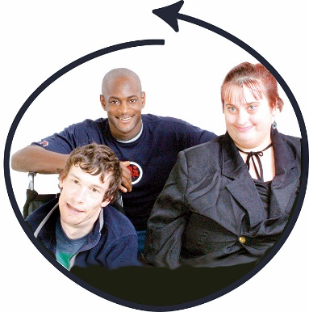

If mainstream services do **not** work for the disabled person then they can try services that are just for disabled people.

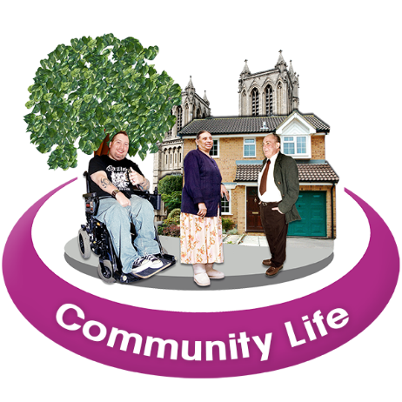  
This means that disabled people:

* can take part in their community
* 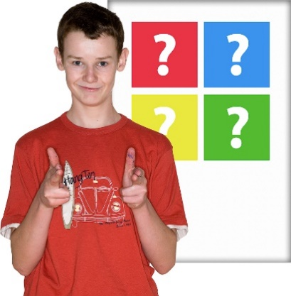are included in their community
* have more choices about what they can do in their community.

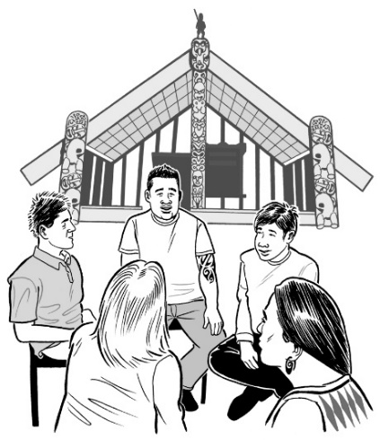**Principle 6 – Mana Enhancing**  
This principle is about respect.   
  
  
**Enhancing** means to make something better.   
  
  
Disabled people and their families / whānau are valued for:   
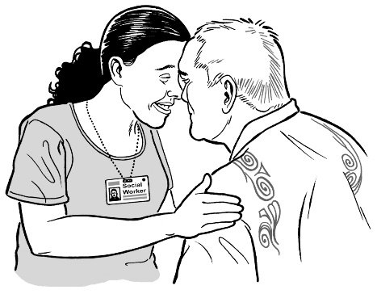

* who they are
* what they can do

Disabled people and their families / whānau are respected.

**Principle 7 – Easy to use**Supports that are put in place for disabled people are:

* easy to use
* flexible – the disability supports fit around the person.

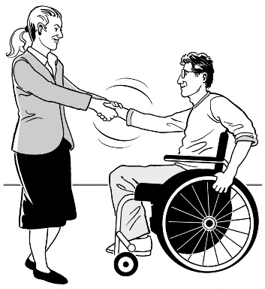**Principle 8 – Relationship building**Supports are put in place for disabled people to make stronger relationships.

  
  
Important relationships disabled people have are with:

* their families / whānau
* 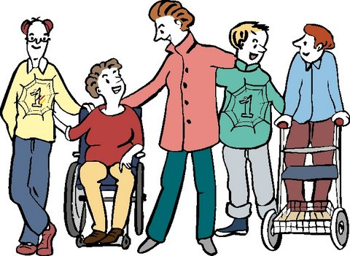their friends
* 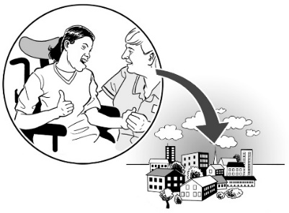other people that are important in a disabled person’s life
* people in their community.

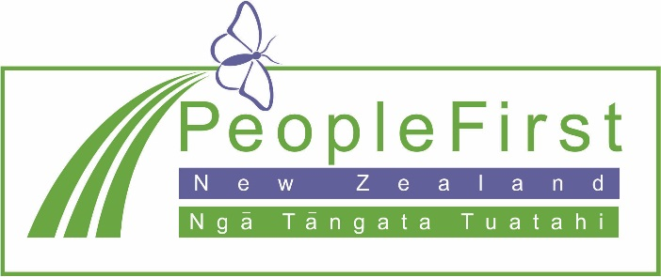

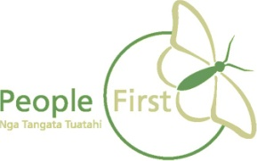**This information has been translated into Easy Read   
by People First New Zealand Inc. Ngā Tāngata Tuatahi**

