MidCentral Governance Group Terms of Reference

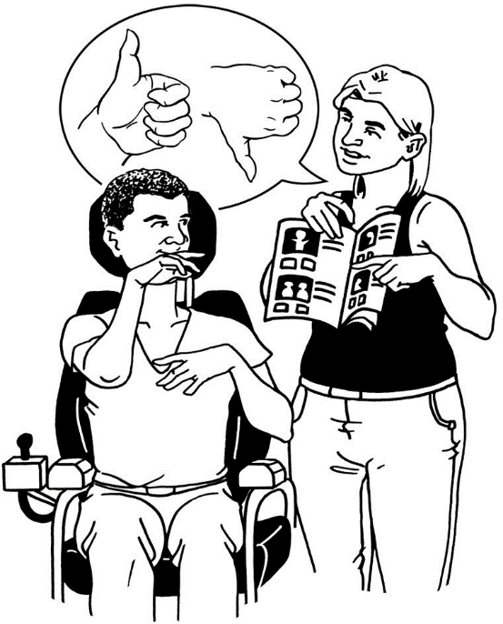
Making sure the new MidCentral disability support system is working well

Easy Read

Before you start

This is a long document.

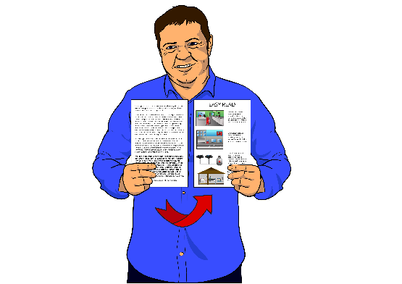
While it is written in Easy Read it can be hard for some people to read a document this long.

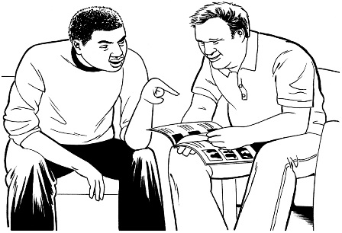
Some things you can do to make it easier are:
- read it a few pages at a time

- have someone help you to understand it.

About the MidCentral Governance Group
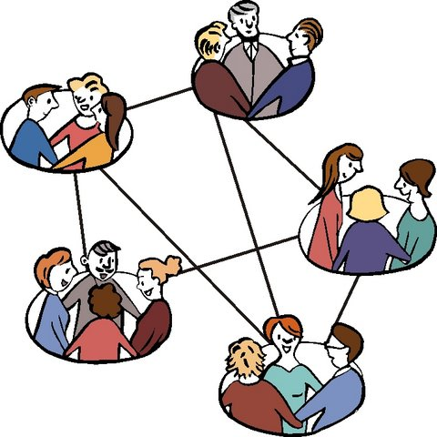
What is a Governance Group?
A Governance Group is a group of people that work together to:
- make sure an organisation does what it sets out to do
- make sure an organisation is run in the way that it needs to so that it can reach its goals
- support an organisation to run smoothly.
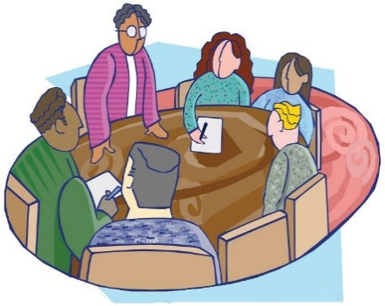
In April 2018 the Cabinet Social Wellbeing Committee started the MidCentral Governance Group.
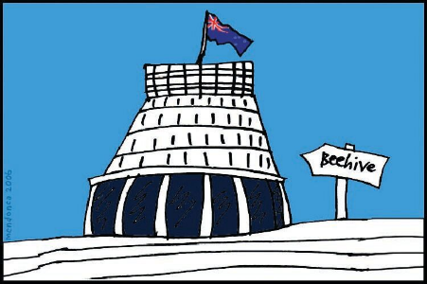
The Cabinet Social Wellbeing Committee is part of the New Zealand Government.

About the MidCentral Governance Group
Terms of Reference

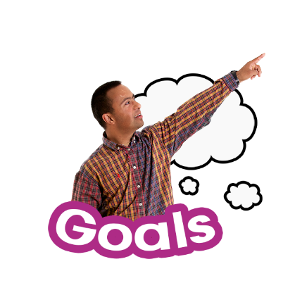
The Terms of Reference of the MidCentral Governance Group:
- sets the goals of the MidCentral Governance Group

- say who can be a member of the MidCentral Governance Group
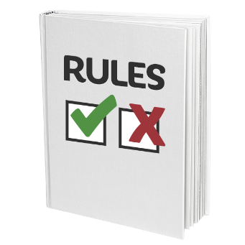
- says the rules of the MidCentral Governance Group.

The Minister for Disability Issues and Associate Minister of Health are:
- part of the New Zealand Government

- work at Parliament.
The Minister for Disability Issues and the Associate Minister of Health are allowed to:
- say if the MidCentral Governance Group Terms of Reference are OK

- change the MidCentral Governance Group Terms of Reference
- say who can be part of the MidCentral Governance Group.

Goals of the MidCentral Governance Group

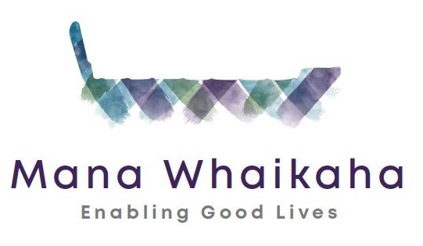
The new disability support system starting in the MidCentral area is called Mana Whaikaha.

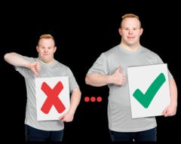
The goals of the MidCentral Governance Group are to:
- watch to see if Mana Whaikaha is working in the way it should be working
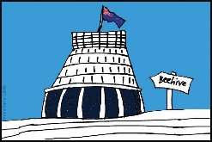
- tell the Minister for Disability Issues and Associate Minister of Health what could be done to make Mana Whaikaha better

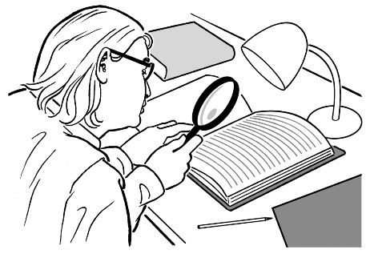
- check Mana Whaikaha is supporting disabled people and whānau / family to make decisions about their lives and supports

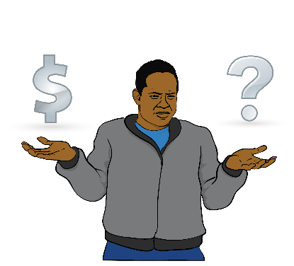
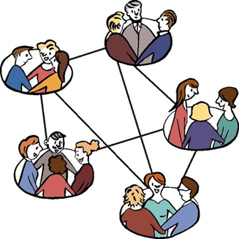
- decide on the most important things to spend money on

- decide on the best ways to get important information to disabled people and their whānau / family
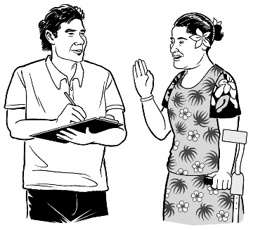
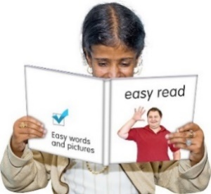
- talk with Kaitūhono / Connectors and Directors of Mana Whaikaha teams to decide what can be done about waiting lists

- read reports about Mana Whaikaha
- ask questions about Mana Whaikaha

- be open about decisions and things they think should happen.

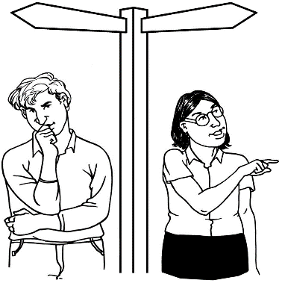
The MidCentral Governance Group is accountable for the strategic direction of Mana Whaikaha.

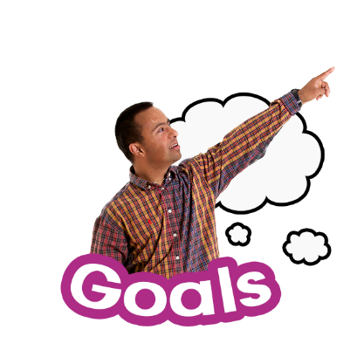
Accountable means to be responsible for something.

Strategic direction means the way things will be done to reach goals that have been set.
The MidCentral Governance Group will not be the managers of:
- people that work in the Mana Whaikaha teams
- how things are done by people that work in Mana Whaikaha.
Members of the MidCentral Governance Group

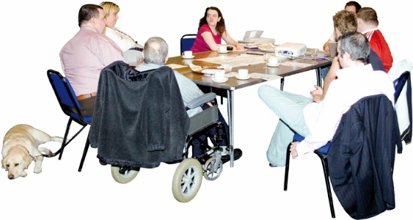
A member of the MidCentral Governance Group is a person that is part of the MidCentral Governance Group.
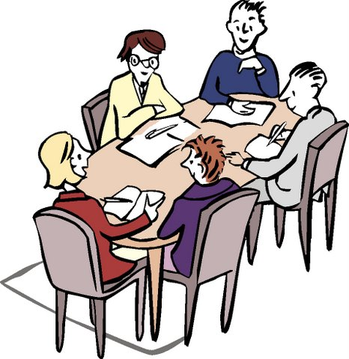
The MidCentral Governance Group will have:
- no more than 9 members

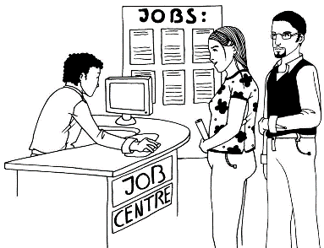
- 2 ex-officio members
Ex-officio means a person that becomes a member because of the kind of work they do.

- 6 members from the MidCentral Leadership Group
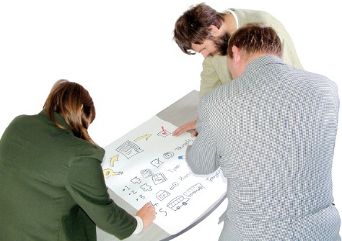
- 3 independent members
Independent means a person that is not from the MidCentral Leadership Group.
The independent members will bring their own experience to the Governace Group to help make Mana Whaikaha better.

1 workforce representative will be 1 of the 3 independent members
.
Workforce representative means a person that knows a lot about jobs.

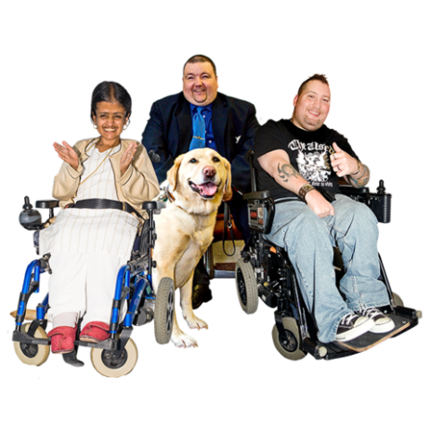
At least half of the MidCentral Governance Group will be:
- disabled people

- whānau / family of disabled people.

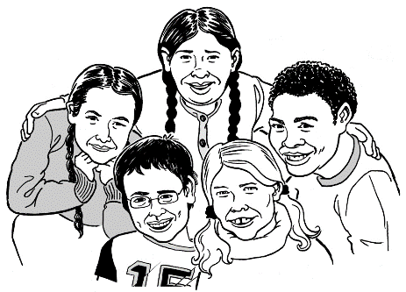
2 members of the MidCentral Governance Group will be ex-officio disabled people who are younger than 25 years.

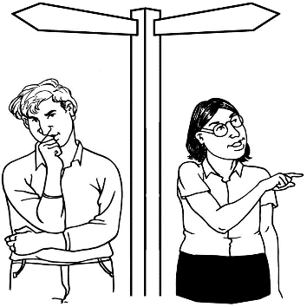
Members will keep being part of the group until all the decisions about running Mana Whaikaha have been made.

This will probably happen at the end of the year 2020.
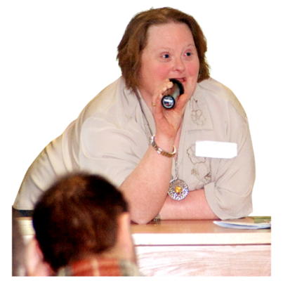
One of the members of the MidCentral Governance Group will be the Chair of the MidCentral Governance Group.

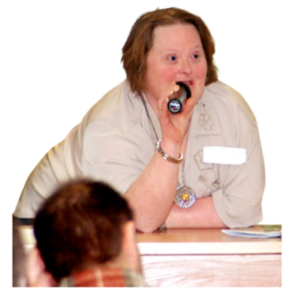
The Chair has to be from the MidCentral Leadership Group.
The job of the Chair is to make sure meetings are run in a good way.

One of the members of the MidCentral Governance Group will be the Deputy Chair of the MidCentral Governance Group.
The Deputy Chair has to be an independent member of the MidCentral Governance Group.
The job of the Deputy Chair is to help the Chair make sure meetings are run in a good way.

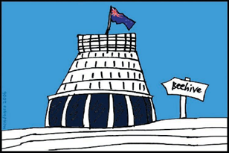
The Minister for Disability Issues and the Associate Minister of Health will decide who will be the:
- Chair
- Deputy Chair.

The MidCentral Governance Group will be supported by a Secretariat.

Secretariat is support that is given to the MidCentral Governance Group to make sure the meetings go well.

The job of the Secretariat is to:
- work with the Chair to make the meeting agenda
An agenda is the list of things to be discussed at a meeting.

The job of the Secretariat is to also:
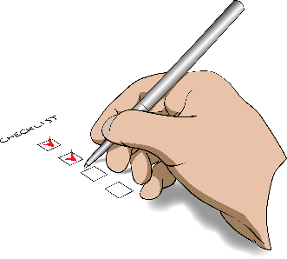
- write what was said and decided at the meeting
- follow up on things that need to be done after the meeting

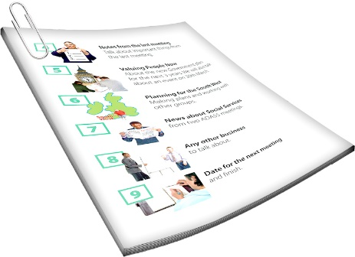
- make sure all the members have the information they need for each meeting

- make sure all members get the meeting papers 3 days before the meeting starts.

Skills MidCentral Governance Group
members need

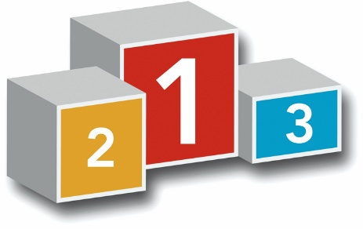
It is important the members of the MidCentral Governance Group have the right skills to be part of the Group.
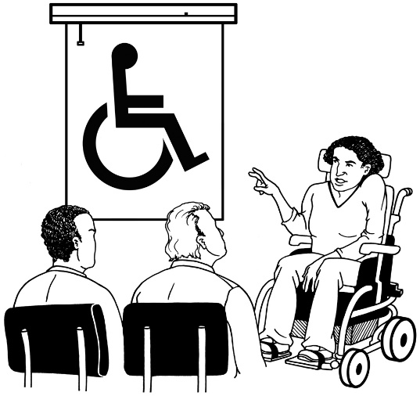
Skills are things that somebody:
- knows

- understands

- is able to do.

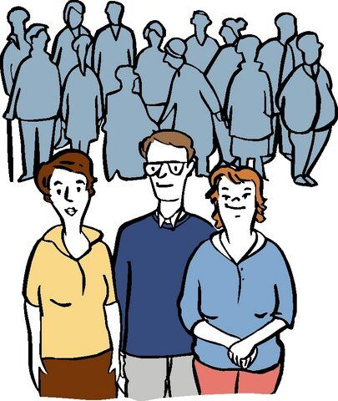
The Minister for Disability Issues and the Associate Minister of Health will say who can be a member of the MidCentral Governance Group.

Members of the MidCentral Governance Group need to understand and believe in:
- Enabling Good Lives goals and ideas
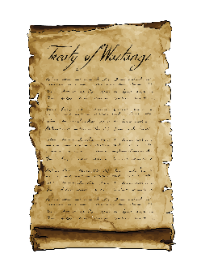
- Te Tiriti o Waitangi / Treaty of Waitangi

- the United Nations Convention on the Rights of Persons with Disabilities

- the United Nations Convention on the Rights of the Child
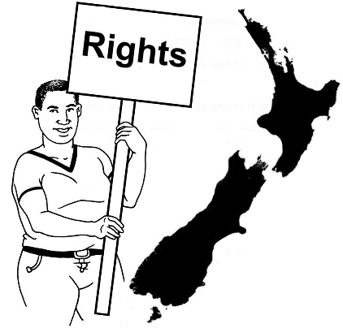
- the New Zealand Disability Strategy

- the rights of disabled people

- supported decision making
- safe guarding decision making.
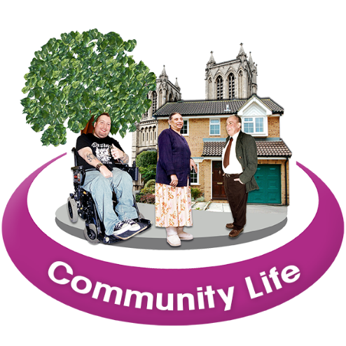
Members of the MidCentral Governance Group need to:
- have strong connections to the local community

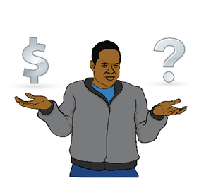
- have used financial management and accountability systems
Financial management is looking after the money side of an organisation.

Accountability systems work to check people are:
- keeping their promises
- doing what they should be doing.

- know a lot about governance
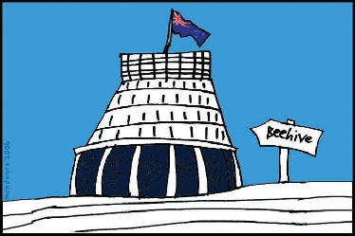
- know a lot about the New Zealand Government system.

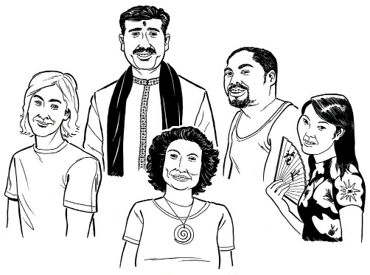
Members of the MidCentral Governance Group need to be:
- fair to everyone

- able to work with lots of different people
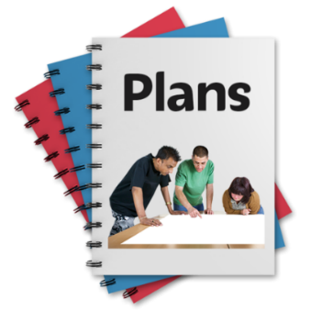
- good at making plans on how to make things better

- good at thinking about how things need to be done to make goals happen
- good at communicating and making relationships with other people

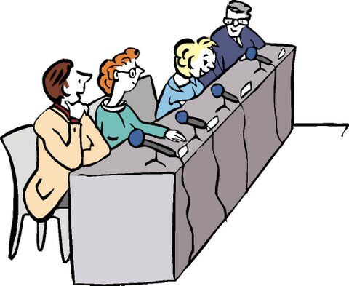
- good at sorting out problems

- good at working out how to make good agreements with other people.
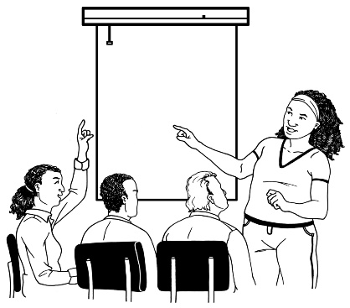
All members of the MidCentral Governance Group will get support to do the job.

They will learn about:
- financial management
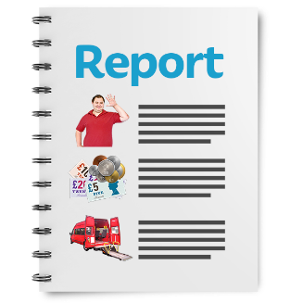
- financial reporting

- governance
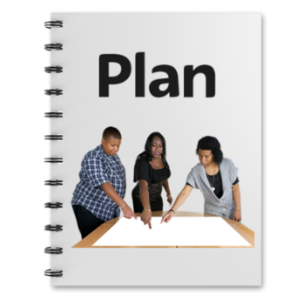
- strategic planning.

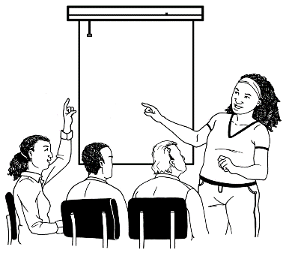
In September 2018 all MidCentral Governance Group members will go to training sessions with people that work in Mana Whaikaha teams.

Rules of the
MidCentral Governance Group

The MidCentral Governance Group will meet every 2 weeks for up to half a day.
In December 2018 a check will be done to see if having the meetings every 2 weeks is good or not.

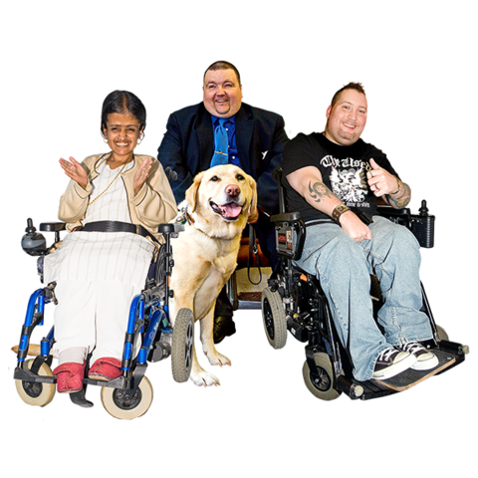
A quorum for the MidCentral Governance Group meeting means:
- there must be 6 members at the meeting

- at least half of the members at the meeting must be disabled people.
A quorum is the number of MidCentral Governance Group members that need to be at the meeting for the meeting to be held.

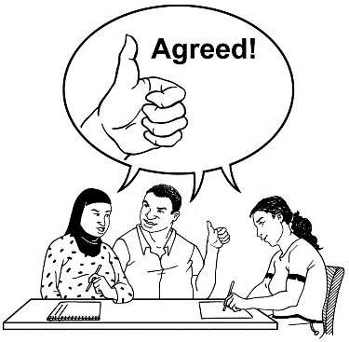
The MidCentral Governance Group will try to have all members agree on all decisions.
Sometimes the MidCentral Governance Group members may not agree on something.
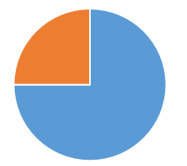
If this happens the decision has to be agreed by 3 quarters of the members at the meeting.

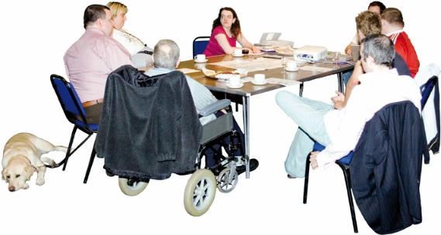
Some other people can go to MidCentral Governance Group meetings:
- to share information with the group
but
- they are not allowed to make decisions.

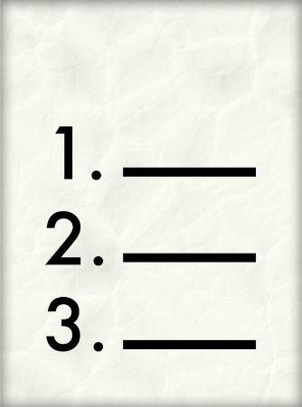
Here is a list of those people:
- directors of Mana Whaikaha

- System Transformation team members

- people from government agencies.

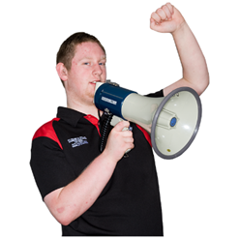
The main job of the MidCentral Governance Group is to tell the Minister for Disability Issues and Associate Minister of Health what should be done to make Mana Whaikaha better.

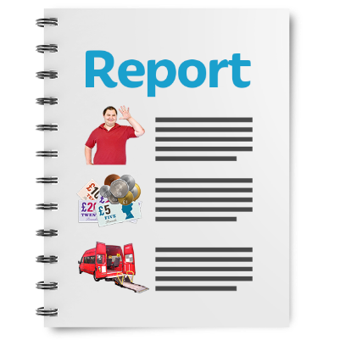
To help them work out what should be done to make Mana Whaikaha better the MidCentral Governance Group will use:
- reports from the Business Insights Specialist
- information from the MidCentral Leadership Group.

They will also use:
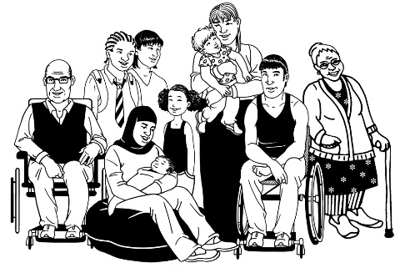
- information from disabled people

- information from whānau / family
- information from other people in the MidCentral area.

If the MidCentral Governance Group and the Ministry of Health do not agree on something the Minister for Disability Issues and Associate Minister of Health will be asked to make the final decision.

Reports and relationships

The Directors and Programme Lead System Transformation of Mana Whaikaha will say the dates for:
- reports on how it is going with Mana Whaikaha
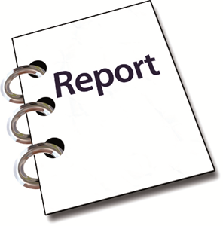
- when the Ministers will get reports from the MidCentral Governance Group.

The MidCentral Governance Group has important relationships with:
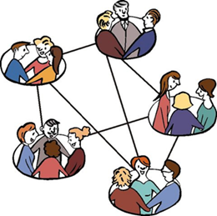
- Minister for Disability Issues

- Associate Minister of Health

- MidCentral Leadership Group.
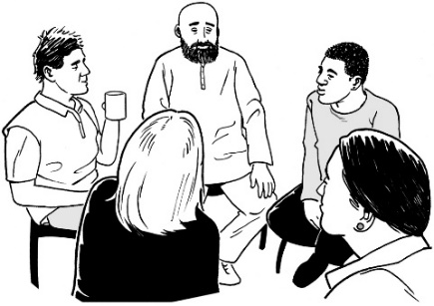
The MidCentral Governance Group has important relationships with:
- Directors of Mana Whaikaha

- Business Insights Specialist from Mana Whaikaha
- Independent Evaluation Team

- National Enabling Good Lives Leadership Group
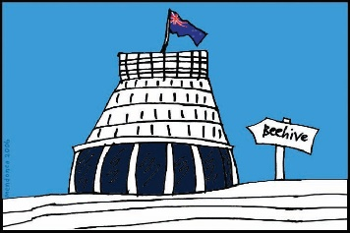
- government agencies
- providers

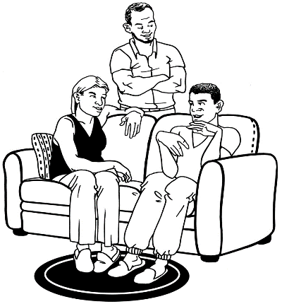
- local organisations
- disabled people and their whānau / families networks and organisations.

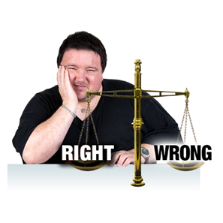
Conflicts of interest

A conflict of interest is when someone cannot make a fair decision because:
- they have something to do with what is being talked about
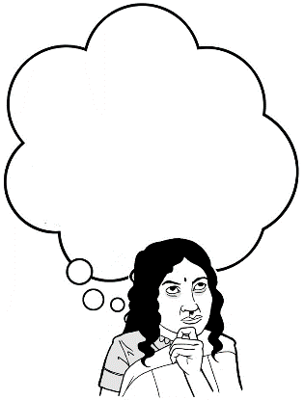
- they could benefit in some way when a decision is made about something they have something to do with.

MidCentral Governance Group members must think about what a conflict of interest will be for them.
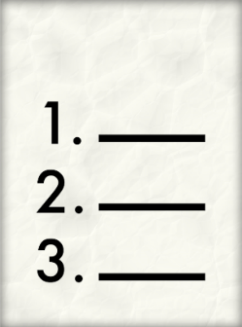
A list of MidCentral Governance Group members’ conflicts of interest will be made.

The things being done to sort out the MidCentral Governance Group members conflict of interest will be written down.

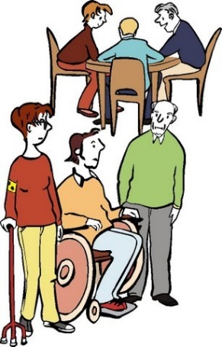
For example a member might not take part in a decision or discussion because there is a conflict of interest.

Code of ethics

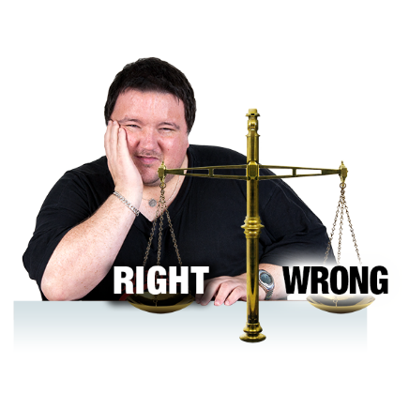
Code of ethics say how we will behave in a way that is fair and right.
There will be a code of ethics for Mana Whaikaha.
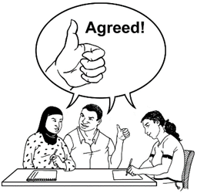
The MidCentral Governance Group will check and agree on the code of ethics with the Mana Whaikaha teams.
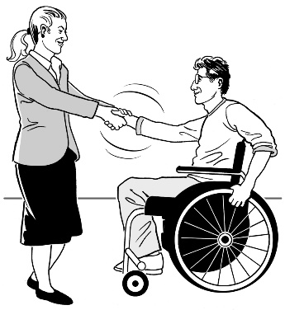
The code of ethics says how the MidCentral Governance Group and the Mana Whaikaha teams will behave.

Confidentiality and privacy

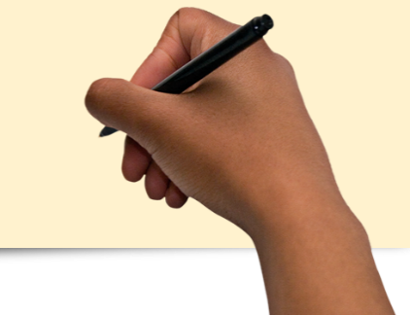
A confidentiality agreement is a document people sign to promise they will not share secret information with anyone.
MidCentral Governance Group members have to sign a confidentiality agreement to promise they will not share information with people not in the Governance Group.

Breach of duty and removal from the Governance Group

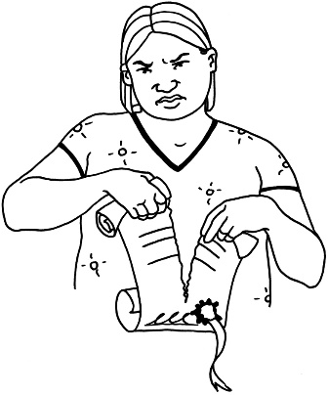
Breach of duty means breaking something like a promise or agreement.

The Minister for Disability Issues and the Associate Minister of Health can stop someone from being a member of the MidCentral Governance Group if the member:
- does not behave in a good way
- does not tell the group about a conflict of interest they have

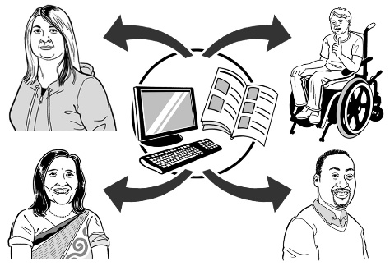
- shares secret information with someone that is not a member of the Governance Group.

More information about the
MidCentral Governance Group

There will be information about all members of the MidCentral Governance Group on the Mana Whaikaha website.

There will be information about how to contact the Chair and Deputy Chair of the MidCentral Governance Group on the Mana Whaikaha website.

The MidCentral Governance Group meeting minutes and actions will be put on the Mana Whaikaha website.

This will happen within 2 weeks after the meeting is held.
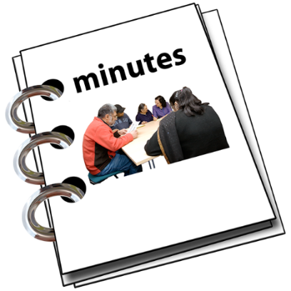
Meeting minutes are written by the secretariat and say:
- who went to the meeting

- things that were agreed at the meeting

- things that were decided at the meeting.
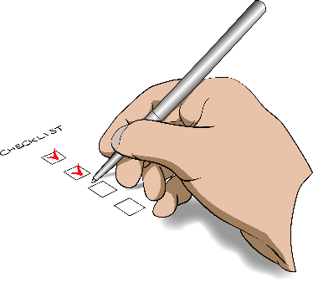
Actions are the things that need to be done after the meeting.

Talking to the media about the
MidCentral Governance Group

The media are things like:
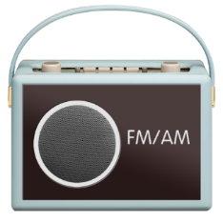
          - newspapers
          - radio
          - social media sites like Facebook
          - television
          - news websites.

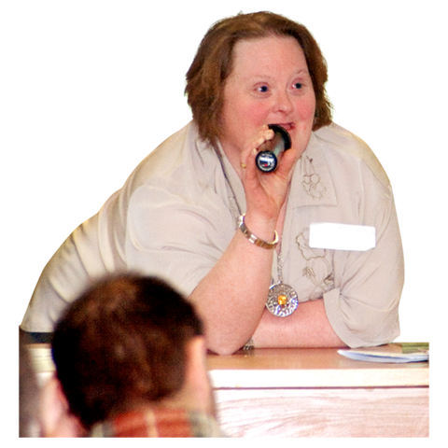
Sometimes people working in the media may want to ask the MidCentral Governance Group questions.

The Chair of the MidCentral Governance Group will work with the Directors on giving answers to the media.
The Chair is the only member of the MidCentral Governance Group that is allowed to talk to the media about the MidCentral Governance Group.

Payments for members

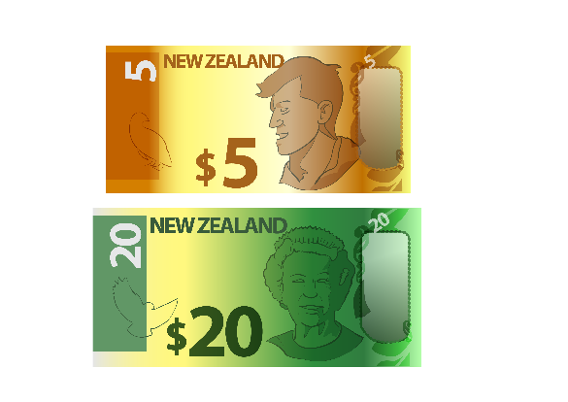
MidCentral Governance Group members will be paid:
- $330 per day for each one day meeting they go to

- some of that money for each half day meeting they go to.

The Chair and Deputy Chair will be paid more money than the other members because they have to do more work.

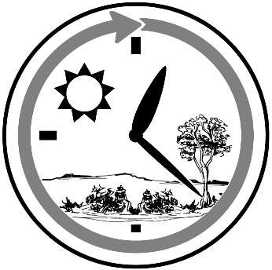
MidCentral Governance Group members will get paid some money for the:
- time it takes to go to meetings

- time it takes to get ready for the meetings

For example reading all the documents before the meeting.
- things to do with the meeting that the member has to pay for.
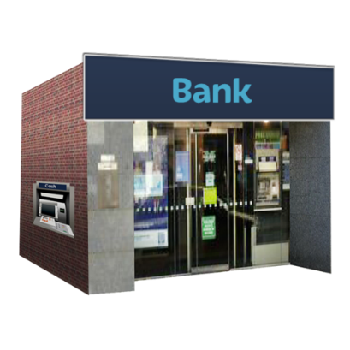
The money to pay the Group member will be put into the bank account the member asks it to be put into.

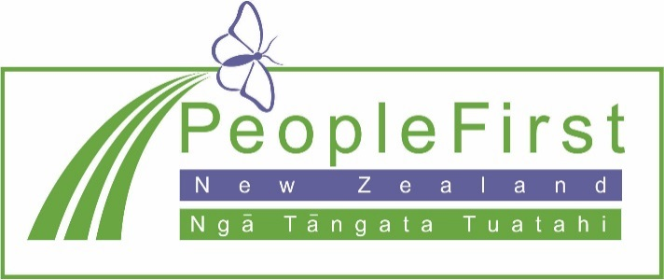

This information has been translated into Easy Read
by People First New Zealand Inc. Ngā Tāngata Tuatahi
