 | MidCentral Governance Group  We ensure the voices and perspectives of disabled people and their whānau are included in the decisions made about the transformed disability support system | Our ‘True North’  Disabled people and whānau have greater choice and  control over their lives and supports (a good life)
Our purpose is to:  - Provide strategic oversight of Mana Whaikaha  - Monitor the implementation and operation of Mana Whaikaha  - Determining the priorities for investment | - Make recommendations to the Minister for Disability Issues and the Associate Minister of Health on how to improve Mana Whaikaha  - Decide the priorities for outreach and the criteria to manage any waitlist to work with a Connector making  - Be transparent about our decisions, recommendations and processes | Enabling Good Lives Vision  In the future, disabled people and their families will have greater choice  and control over their lives and supports, and  make more use of natural and universally available supports  Enabling Good Lives Principles
 |  | - Self determination  - Person centred  - Mana enhancing  - Easy to use | - Begin early  - Ordinary life outcomes  - Mainstream first  - Relationship building
Our decisions:  - Contribute to ‘True North’  - Align with the EGL Vision and Principles  - Align with the Ministers’ expectations  - Prioritise the early investment priorities | We take a Try, Learn and Adjust approach to decisions by asking ourselves:  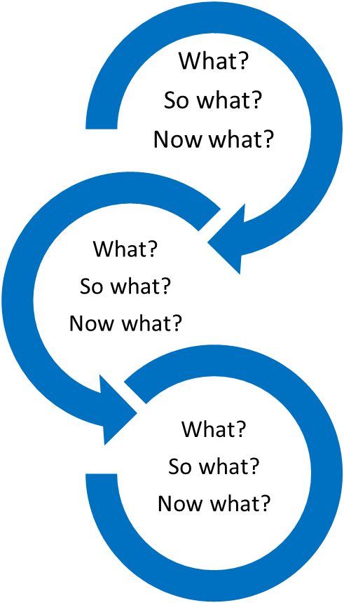 | Ministers’ expectations of Mana Whaikaha  - Provides disabled people and their whānau with more options and decision-making about their lives and supports  - Improves the outcomes for disabled people and their whānau  - Creates a more cost effective disability support system
Some of the key documents that guide our decision:  - The Ministers’ letter of expectations  - Our Terms of Reference  - Our Code of Conduct  - EGL principles alignment template that is included in every decision paper |  | Priorities for early investment  - Achieving a sustainable accommodation situation, independent of residential care  - Invest early in responses to challenging behaviour (including broader responses)  - Building a broader informal support network  - Building and achieving the potential of disabled children  - Improving employability, or employment status

