MidCentral Governance Group
Minutes of the meeting held on Thursday 24 October 2019
Attendees: | Peter Allan (Chair), Heather Browning (Deputy Chair),Martin Sullivan, Rachel Kenny, Rasela Fuauli, Peter Ireland, Angela Hobden, Maxine Dale, Zandra Vaccarino
Apologies:
In attendance: | Jo Brew  Sandy Ryan
Venue: | Conference Room, EASIE Living Centre, 585 Main Street, Palmerston North
Time: | 11.00am – 3.00pm

Karakia
Update: Ministers visit
Minister Salesa’s visit deferred until next meeting on Thursday 28 November.
Information: Feedback of MGG/MoH/Enable New Zealand meeting
The three parties discussed and agreed on six outcomes relating to shared measures of success, reporting information requirements, working to decrease “wait times”, feedback on the implementation of agreed actions, a budget for Governance Group self-management and information sharing, cohesion and collaboration.
Discussion: Reporting Priorities
The group discussed shared information/reporting requirements including
- evidence of cross government approach in terms of how value and impact
- early investment priorities (and criteria for assessment)
- using Ministers expectations for reporting
- outcomes of Try, Learn, Adjust
- statistics and information about the waiting list and solutions to decrease the waitlist
- key performance indicators
Information: Monitoring Report
Bre McQuade, Business Insight Specialist, tabled the June Monitoring Report and shared the July – September quarterly report had been submitted to Ministry of Health. Bre gave an update on the CRM software development upgrade and the planned upgrades to each phase. Phase 1 is expected to be operational in early December and phase 2 is expected to go live in April 2020. Full training will be given to staff with an emphasis of accurate information and alignment of information being entered into the system enabling accurate reporting.
Information: Operational update from Directors
Lorna Sullivan and Marshall Te Tau gave operational updates on reporting matters, priorities and requirements for the CRM development phases, successes including the reduction of people going into residential, progress with challenging behaviours, building competency around circles of support and engaging potential employers via the Chamber of Commerce. There is a lack of employment support for people wishing to/entering into the workforce, a lack of capacity at present inhibits community investment and resourcing in this area.
Discussion: Try, Learn, Adjust Meeting Feedback
The group discussed the recent Try, Learn, Adjust meeting, the results of the baseline study results and anticipate the release of the full report.

Practical matters

Date of next meeting: Thursday 28 November 2019, 11.00 am, Conference Room, Level 2, 585 Main Street, Palmerston North

I confirmed that these minutes constitute a true and correct record of the proceedings of the meeting

DATED this 3rd day of December 2019

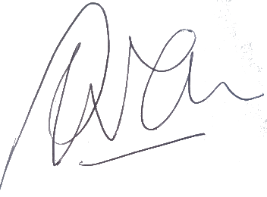

Peter Allen
Chair, MidCentral Governance Group

