MidCentral Governance Group
Minutes of the meeting held on Thursday 26 September 2019
Attendees: | Peter Allan (Chair), Martin Sullivan, Rachel Kenny, Rasela Fuauli, Peter Ireland, Heather Browning (Deputy Chair), Angela Hobden, Maxine Dale, Zandra Vaccarino
Apologies: | Rasela Fuauli
In attendance: | Jo Brew
Venue: | Conference Room, Level 2, 585 Main Street, Palmerston North
Time: | 11.00 – 3.00pm

Karakia
Discussion: Matters tabled by members
The group shared community network matters including traditional day services, flexible disability support contacts and the need of representation of disabled persons or persons with lived experience on organisations health and disability governance groups.
Discussion: Directors Updates from a special ‘Reset Meeting’
The group reflected on matters and challenges regarding team structure, resourcing, capacity, reporting, timelines and workflow to assist with prototype refinement.
Inwards Correspondence:
- Early Investment Priorities.
- Email of Congratulations re Leadership in Governance Award of the Spirit of Service awards.
- Livestream Conversation link details
- Response of acknowledgement – System Review
- Questions for gathering feedback.
Information: Timeframe Data
Paul Miller, Principal Advisor – System Transformation reported on the timeframes processing immediate resourcing and personal budgets from submission of proposal to funding approval. Various factors affect the workflow process and consequently the timeframes.
Information: Client Relationship Management Project
Donna Dyer, Business Analyst and Bre McQuade, Business Insight Specialist reported on the progress of the Client Relationship Management (CRM) Project. Tenders close on Friday 4 October. The first upgrade to this software will be expected by the end of November 2019. Data input is crucial to CRM for future reporting.

Practical matters

Date of next meeting: Thursday 24 October 2019, 11.00 am, EASIE Living Conference Room, 585 Main Street, Palmerston North

I confirmed that these minutes constitute a true and correct record of the proceedings of the meeting

DATED this 3rd day of December 2019

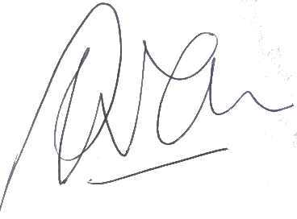

Peter Allen
Chair, MidCentral Governance Group

